MEE 352 Project 2
Design of a Heat Exchanger

Luke Schwaller
Scot Bishop
Clayton Brown

12/6/19

Problem Statement:

Heat exchangers are a common implementation, valued for their ability to transfer heat from one fluid to another. Often found in air-conditioning units, heaters, and radiators these heat exchangers can also be found in many industrial settings, such as electrical generation stations and cooling systems for production plants. For the purpose of the current project a chemical production plant requires a heat exchanger to regulate the temperature of the chemical during the production cycle. The type of exchanger has not been regulated but the key factor has been stated as a reduction of both weight and overall volume.
In the interest of creating an efficient heat exchanger for usage in a chemical treatment plant three key types of heat exchangers are available for the selection process; cross-flow, concentric tube, or shell-and-tube. Cross flow heat exchangers use an array of fins to channel fluid flow around a bank of tubes. The fins create a barrier to flow along the length of the tubes forcing the cross flow to occur at a perpendicular angle and generating an “unmixed” flow. Contrary to this perpendicular flow pattern concentric tube systems use parallel flow and counter flow to induce the heat exchange. This system can be as simple as two circular tube with one nested within the other or it can be improved and complicated through the usage of fins within the flow, which increases surface area of the transfer surface. Finally, shell-and-tube systems utilize a bank of tube nested within an outer shell through which the fluid is forced to take a nonlinear path inducing turbulence as it goes. This method implements baffles as supports for the tubes while inducing turbulence within the flow path which subsequently improves the convection coefficient.

Problem Specification:

With these types of heat exchangers, the goal is creating a high efficiency compact system. For the current problem, the task is the cooling of a chemical, the properties of which can be approximated as water, from $80℃$to $25℃$while the mass flow rate is 20kg/s. The cooling process is to be facilitated through the usage of tap water which has an initial temperature of $20℃$ and a flow rate of 40kg/s. With these constraints, the process is an optimization problem to determine efficiencies and reducing the volume and weight of the system.

Design Approach:

When determining the most effective heat exchanger type the first option evaluated was designing a tube annulus through the usage of fins and crossflow, however due to the unusual geometry without a given convection coefficient the calculation was beyond the current understanding. Following this a shell and tube heat exchanger was attempted but once again the very odd geometry, which is a result of the multiple passes within the flow, leading to complications in calculating the Nusselt number. Following this a brief attempt was made to determine a method for utilizing a crossflow heat exchanger but eventually it was determined that a return to a simplified version of our initial design was the most attainable process. This led to the utilization of a counter flow annulus type heat exchanger.
This heat exchanger was built to have a variable length and diameter so that an optimal design could be found. With this approach in mind a code was developed that would iteratively verify lengths and diameters for the entire structure. With counterflow being one of the more efficient of the annulus tubes this design allows for an effective reduction of the chemical’s output temperature to within the desired range. In order to calculate heat transfer it was assumed that the tube wall between the chemical and water will be treated as a thin wall to minimize thermal resistance. Much in the same vein it was assumed that the outermost shell of the tube is well insulating and therefore does not allow any heat transfer into the system from the surroundings. An assumption was also utilized stating that the Nusselt number calculation for the outer annulus could be carried out in the same methodology as a standard tube with the modification coming as a result of hydraulic diameter.
Design Analysis:

To find the heat transfer rate, an energy balance is used.
$${q=\dot{m}}_{h}c_{p,h}\left(T_{h,i}-T_{h,o}\right)$$
Once the heat transfer rate is found, the water outlet temperature is
$$T_{c,o}=\frac{q}{{\dot{m}}_{c}c_{p,c}}+T_{c,i}$$
This temperature is iterated as the average temperature of the cold fluid is adjusted when T_{c,o} is calculated, and fluid properties are updated via interpolation.
The required heat exchanger length can now be found using
$$q=UA {∆T}_{lm}$$
where $A= πD_{i}L$ and
$${∆T}_{lm}=\frac{\left(T_{h,i}-T_{c,o}\right)-\left(T_{h,o}-T_{c,i}\right)}{\ln\left[\left(T_{h,i}-T_{c,o}\right)/\left(T_{h,o}-T_{c,i}\right)\right]}$$

The overall heat transfer coefficient is
$$\boxed{U=\frac{1}{\left(1/{h_{i}}\right)+\left(1/{h_{o}}\right)}}$$
Length can now be written as
$$\boxed{L=\frac{q}{UπD_{i}{∆T}_{lm}}}$$
This will be solved once the total heat transfer coefficient is determined.
For water flow through the tube,
$${Re}_{D}=\frac{4{\dot{m}}_{c}}{πD_{i}μ}$$
In this problem, since the flow was found to be turbulent, the Nusselt number was calculated by
$${Nu}_{D}=0.023{ Re}_{D}^{4/5}{Pr}^{0.4}$$
Hence
$h_{i}={Nu}_{D}\frac{k}{D_{i}}$
For the flow of water through the annulus, the Reynolds number is calculated by using the hydraulic diameter:
$$D_{h}=D_{o}-D_{i}$$
This is used to find the Reynold’s number which changes the equation to
$${Re}_{D}=\frac{4{\dot{m}}_{c}}{π\left(D_{o}+D_{i}\right)μ}$$
Now that the convection coefficient for both the tube and annulus is found, the total heat transfer coefficient is calculated, and then the length of the heat exchanger is calculated as given above (boxed).

To start the evaluation of our chosen system we created a program that would allow us to do all of the above analysis on an iterative cycle allowing us to change our volumetric parameters and analyze the system without having to manually redo calculations. To start with within python, we created a “method” (aka function) that can interpolate when given values to interpolate between. This is critical as it allows us to calculate temperatures during the codes operation, and then immediately use them, without having to pause the code to find properties at the calculated temps and manually input them.
def Interpolate(High_1,High_2,Low_1,Low_2,Value_1):
Step_2 = (1/(((High_1 - Low_1)/(High_1 - Value_1))/(High_2-Low_2)))
Final = abs(Step_2 - High_2)
return(Final)
Additionally, it became apparent that we would need to calculate the area of our pipes repetitively, which meant the development of a second function for area calculations.
def get_area_cylinder(Diameter,Length):
Area = 2*3.14*(Diameter/2)*Length
return(Area)
Once these repetitive calculations had unique methods, the systems parameters needed to be defined, as they don’t change as the loop iterates, since boundary conditions for the temperature were prescribed in the problem statement.
Cp_H = 4196
Cp_C = 4182
M_H = 20
M_C = 40
Viscocity_H = Interpolate(85,335.4,20,1007.4,52.5)
Pr_h= Interpolate(85,.9563999,20,0.8458,52.5)
Therm_k_H = (Interpolate(85,672.8,20,602.8,52.5)*10**(-3))
output = pd.DataFrame(columns=["Dia_inner","Re_inner","h_inner","Dia_outer","Re_outer","h_outer","U","Length","Area_inner","Area_outer","Vol_inner","Vol_outer","Vol_total","Weight_inner","Weight_outer","Weight_total"])
T_hi = 80
T_Ci = 20
T_ho = 25
Dia_inner = .00025
Dia_outer = .00045
With these parameters defined, the main loop could be programmed. The main loop cycles through the necessary equations to calculate the length of the tube based on input system diameters. To start this loop, it is necessary to find the outlet temperature, and therefor the log mean temperature. With this temperature the system properties for the cold fluid can then be interpolated.
while Dia_inner<.5:
q_gen = M_H*Cp_H*(T_hi-T_ho)
T_co = (q_gen/(M_C*Cp_C))+T_Ci
T_cEval= (T_Ci+T_co)/2
Viscoity_C = Interpolate(85,335.4,20,1007.4,T_cEval)
Therm_K_C = (Interpolate(85,672.8,20,602.8,T_cEval)*10**(-3))
Pr_C = Interpolate(85,.9563999,20,0.8458,T_cEval)
T_lm = ((T_hi-T_co)-(T_ho-T_Ci))/(np.log((T_hi-T_co)/(T_ho-T_Ci)))
With these system properties all defined, it is then possible to calculate the relevant heat transfer properties(Reynolds, Nusselt, Heat Transfer Coefficients) of the system as follows.
Re_inner = (4*M_C)/(3.14*(Viscoity_C*10**(-6))*Dia_inner)
Nu = .023 * ((Re_inner) ** (4 / 5)) * ((Pr_C) ** (.4))
h_inner = (Nu * Therm_K_C)/Dia_inner
Dia_H = Dia_outer - Dia_inner
Dia_re = (Dia_outer+Dia_inner)
Re_outer = (4*M_H)/(3.14*Dia_re*(Viscocity_H*10**(-6)))
Diameter_ratio = Dia_inner/Dia_outer
Nusselt = .023 * ((Re_outer) ** (4 / 5)) * ((Pr_h) ** (.4))
h_outer = (Nusselt*Therm_k_H )/Dia_H
U = (1/((1/h_inner)+(1/h_outer)))
Length = q_gen/(U*3.14*Dia_inner*T_lm)
The calculation of this final length creates full knowledge of the system, which therefor allows us to evaluate the system and understand if the solution approaches one that is optimized for volume and weight as the problem statement requests. These properties are calculated as follows.
Density_h = Interpolate(87, 1034, 17, 1000, 52.5)
Density_c = Interpolate(87, 1034, 17, 1000, T_co)
Vol_total = (3.14*(Dia_outer/2) *Length)
Vol_inner = (3.14*(Dia_inner/2) *Length)
Vol_outer = (3.14*((Dia_outer - Dia_inner)/2) *Length)
Weight_inner = (Density_c*Vol_inner)
Weight_outer = (Density_h*Vol_outer)
Weight = (Weight_inner + Weight_outer)
Area_inner = get_area_cylinder(Dia_inner,Length)
Area_outer = get_area_cylinder(Dia_outer,Length)
At this point the code is able to complete the loop, iterating through and solving every configuration of diameters for an applicable length. Additionally, this data is then output into an excel sheet for easy usability, and code is implemented to allow the output of various graphs depending upon the desired parameters to compare.
output = output.append({"Dia_inner":Dia_inner,"Re_inner":Re_inner,"h_inner":h_inner,"Dia_outer":Dia_outer,"Re_outer":Re_outer,"h_outer":h_outer,"U":U,"Length":Length,"Area_inner":Area_inner,"Area_outer":Area_outer,"Vol_inner":Vol_inner,"Vol_outer":Vol_outer,"Vol_total":Vol_total,"Weight_inner":Weight_inner,"Weight_outer":Weight_outer,"Weight_total":Weight}, ignore_index=True)
print(Dia_outer)
Dia_inner += .0005
Dia_outer += .0005
print(output)
output.plot(x='Dia_inner',y='Weight_total')
output.to_excel(r'C:\Users\lksch\PycharmProjects\352project2\data.xlsx')
plt.show()

The full code as a whole can also be viewed in Appendix A

Final Design Selection:
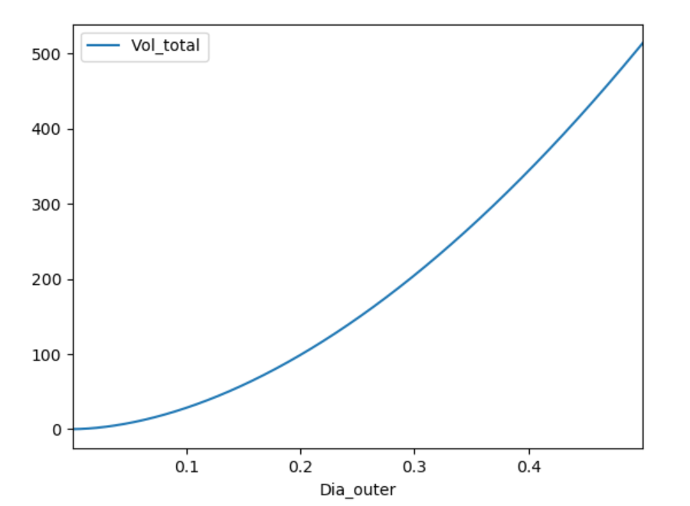
Based off data output from the above a graph was generated to compare the total volume of the system to the outer diameter. The output graph can be viewed as Figure 1.
Figure 1
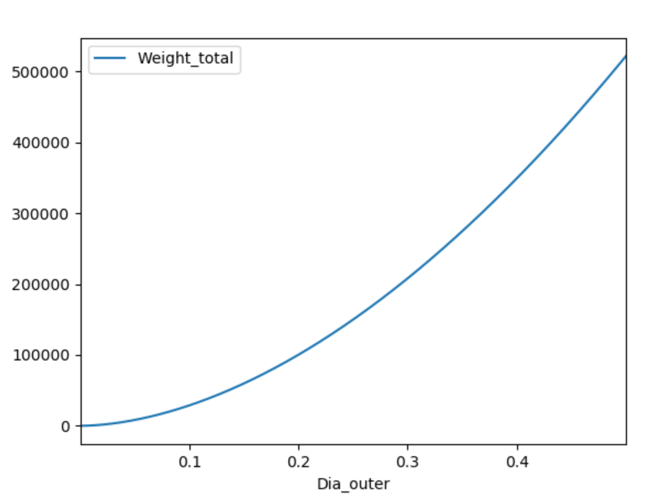
Based on this graph it was concluded that the smallest system diameter would provide the most optimal volumetric design, and therefor the most optimal weight. This was confirmed by comparing the outer diameter to the total weight of the system.
Figure 2

With this knowledge the output excel sheet was analyzed to find the minimum volume, which occurred at the lowest diameter of .0035 meters. The following data was output for this point, as well as 2 surrounding points.

 | Dia_inner | Re_inner | h_inner | Dia_outer | Re_outer | h_outer | U | Length
0 | 0.00035 | 1.68E+08 | 1.46E+08 | 0.00045 | 47433920 | 1.95E+08 | 83496663 | 3.429938
1 | 0.00085 | 69321932 | 29608456 | 0.00095 | 21081742 | 1.02E+08 | 22933608 | 5.142001
2 | 0.00135 | 43647142 | 12875646 | 0.00145 | 13552549 | 71439485 | 10909424 | 6.805935
Table 1:

 | Area_inner | Area_outer | Vol_inner | Vol_outer | Vol_total | Weight_inner | Weight_outer | Weight_total
0 | 0.003769502 | 0.0048465 | 0.00188475 | 0.0005385 | 0.002423 | 1.91275642 | 0.547785541 | 2.460541961
1 | 0.013724 | 0.01533859 | 0.006862 | 0.0008073 | 0.007669 | 6.963962298 | 0.821214155 | 7.785176453
2 | 0.02885036 | 0.03098742 | 0.01442518 | 0.0010685 | 0.015494 | 14.63952388 | 1.086956402 | 15.72648028

This results in the final system having the following parameters:

Property | Temp Cold-in | Temp Cold-out | Temp Hot-In | Temp Hot-Out | Inner Diameter | Outer Diameter
Value | 20$℃$ | 47.69$℃$ | 80$℃$ | 25$℃$ | .35 mm | .45 mm
Property | Inner Volume | Outer Volume | Total Volume | Total Weight | Material | Exchanger Type
Value | 0.001884 m³ | 0.000538 m³ | 0.002423 m³ | 2.4605419 Kg | Carbon | Counterflow - Annulus

Appendix
A.)
import ht
import pandas as pd
import math
import matplotlib.pyplot as plt
import numpy as np
def Interpolate(High_1,High_2,Low_1,Low_2,Value_1):
Step_2 = (1/(((High_1 - Low_1)/(High_1 - Value_1))/(High_2-Low_2)))
Final = abs(Step_2 - High_2)
return(Final)
def get_area_cylinder(Diameter,Length):
Area = 2*3.14*(Diameter/2)*Length
return(Area)
Cp_H = 4196
Cp_C = 4182
M_H = 20
M_C = 40
Viscocity_H = Interpolate(85,335.4,20,1007.4,52.5)
Pr_h= Interpolate(85,.9563999,20,0.8458,52.5)
Therm_k_H = (Interpolate(85,672.8,20,602.8,52.5)*10**(-3))
output = pd.DataFrame(columns=["Dia_inner","Re_inner","h_inner","Dia_outer","Re_outer","h_outer","U","Length","Area_inner","Area_outer","Vol_inner","Vol_outer","Vol_total","Weight_inner","Weight_outer","Weight_total"])
T_hi = 80
T_Ci = 20
T_ho = 25
Dia_inner = .00035
Dia_outer = .00045
while Dia_inner<.5:
q_gen = M_H*Cp_H*(T_hi-T_ho)
T_co = (q_gen/(M_C*Cp_C))+T_Ci
T_cEval= (T_Ci+T_co)/2
Viscoity_C = Interpolate(85,335.4,20,1007.4,T_cEval)
Therm_K_C = (Interpolate(85,672.8,20,602.8,T_cEval)*10**(-3))
Pr_C = Interpolate(85,.9563999,20,0.8458,T_cEval)
T_lm = ((T_hi-T_co)-(T_ho-T_Ci))/(np.log((T_hi-T_co)/(T_ho-T_Ci)))
Re_inner = (4*M_C)/(3.14*(Viscoity_C*10**(-6))*Dia_inner)
Nu = .023 * ((Re_inner) ** (4 / 5)) * ((Pr_C) ** (.4))
h_inner = (Nu * Therm_K_C)/Dia_inner
Dia_H = Dia_outer - Dia_inner
Dia_re = (Dia_outer+Dia_inner)
Re_outer = (4*M_H)/(3.14*Dia_re*(Viscocity_H*10**(-6)))
Diameter_ratio = Dia_inner/Dia_outer
Nusselt = .023 * ((Re_outer) ** (4 / 5)) * ((Pr_h) ** (.4))
#if (Diameter_ratio >.5):
# Nusselt = Interpolate(1,4.86,0.5,4.43,Diameter_ratio)
#else:
# print('ratio doesnt hold')
h_outer = (Nusselt*Therm_k_H )/Dia_H
U = (1/((1/h_inner)+(1/h_outer)))
Length = q_gen/(U*3.14*Dia_inner*T_lm)
Density_h = Interpolate(87, 1034, 17, 1000, 52.5)
Density_c = Interpolate(87, 1034, 17, 1000, T_co)
Vol_total = (3.14*(Dia_outer/2) *Length)
Vol_inner = (3.14*(Dia_inner/2) *Length)
Vol_outer = (3.14*((Dia_outer - Dia_inner)/2) *Length)
Weight_inner = (Density_c*Vol_inner)
Weight_outer = (Density_h*Vol_outer)
Weight = (Weight_inner + Weight_outer)
Area_inner = get_area_cylinder(Dia_inner,Length)
Area_outer = get_area_cylinder(Dia_outer,Length)
output = output.append({"Dia_inner":Dia_inner,"Re_inner":Re_inner,"h_inner":h_inner,"Dia_outer":Dia_outer,"Re_outer":Re_outer,"h_outer":h_outer,"U":U,"Length":Length,"Area_inner":Area_inner,"Area_outer":Area_outer,"Vol_inner":Vol_inner,"Vol_outer":Vol_outer,"Vol_total":Vol_total,"Weight_inner":Weight_inner,"Weight_outer":Weight_outer,"Weight_total":Weight}, ignore_index=True)
print(Dia_outer)
Dia_inner += .0005
Dia_outer += .0005
print(output)
output.plot(x='Dia_inner',y='Weight_total')
output.to_excel(r'C:\Users\lksch\PycharmProjects\352project2\data.xlsx')
plt.show()

